Directions: The goal of the following problems is to help challenge and deepen your understanding of the current topic. Don’t assume that you will know how to answer every question. You will work with at least two other students in the class to try and find solutions and write arguments for each of the following questions. Be sure that you question your classmates’ reasoning. If you don’t understand how they are getting something, you should ASK THEM TO EXPLAIN! Being able to defend your reasoning is important and so you are actually helping them by asking them to explain.

Challenge Questions

- Consider the region given by the following curves: .
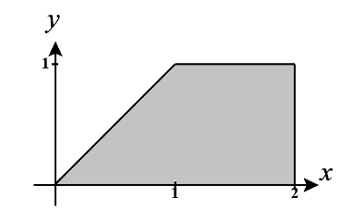
- When the region is rotated about the y-axis determine if you need dx or dy integrals for washers/disks and for shells.

Shells would be set up with respect to x.
Washers/disks would be set up with respect to y.

- Set up, but do not evaluate, a dy and a dx integral(s) that represent the volume of the resulting solid.

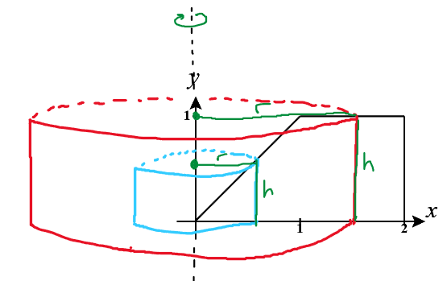

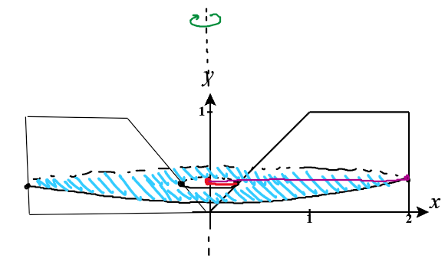

- Consider the region given by the following curves: .
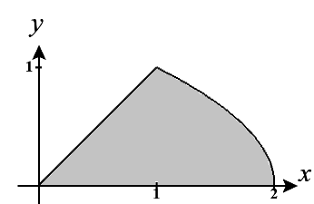
- When the region is rotated about the line determine if you need dx or dy integrals for washers/disks and for shells.

Shells would be set up with respect to y.
Washers/disks would be set up with respect to x.

- Set up, but do not evaluate, a dy and a dx integral(s) that represent the volume of the resulting solid.

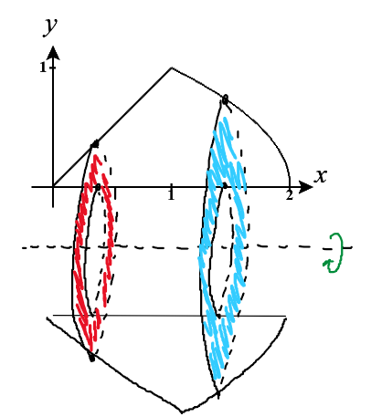

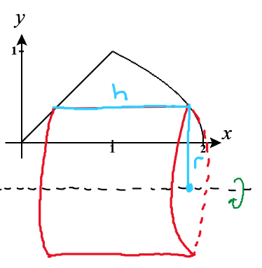

- Consider the region R which is bounded by the curves . Suppose that R is rotated around the line .

- Determine the volume of the resulting solid by integrating with respect to x.

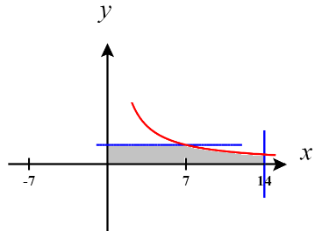
A picture of the region R is shown below. If this is revolved around the line we note that shells move in the dx direction. Notice though that the height of the shells will be different before and after . Therefore, we need to tackle this using two integrals.

We have that
These integrals now in a form that will be easy to evaluate.

- Determine the volume of the resulting solid by integrating with respect to y.

If this is revolved around the line we note that washers move in the dy direction. Notice though that the outer radius of the washers will be different before and after . Therefore, we need to tackle this using two integrals. We have that

- In the diagram below, the equation of the curve and the equation of the line is . Let be the volumes of the solids obtained by revolving the shaded region bounded by the curve and line about the x-axis and y-axis, respectively. If then what is the value of m?
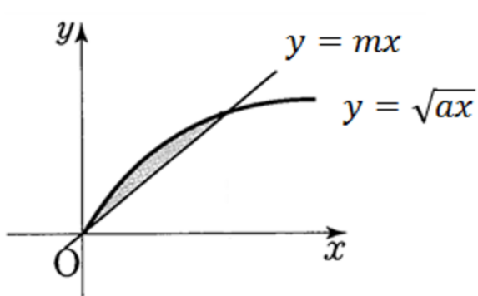

We first find the intersection of the curve and the line.
Therefore, intersection points occur at

The volume of the solid obtained by rotating the region about the x-axis is given by

The volume of the solid obtained by rotating the region about the y-axis is given by

Since we want these volumes to be equal, we must have that

- The beads for a bracelet are spheres of radius 5mm with a hold of radius 3mm drilled through the center so that they can be threaded together. What is the volume, in , of material removed from the bead when the hold is drilled?

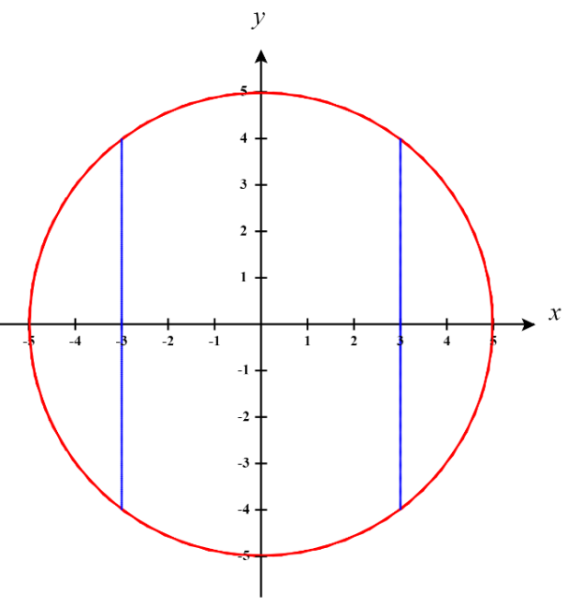
A 2-demensional representation of this scenario is shown below. The circle of radius 5 represents the sphere of radius 5 and the region between the blue lines is the portion of the bead that will be drilled out.

Note that if we take just one half of this diagram (as shown in the next image) we can rotate the region inside the circle and between the y-axis and the blue line about the y-axis to generate the space the represents the volume which is drilled out from a bead.

Note that the equation of the circle is given by where represents the top half of the circle and represents the bottom half of the circle.

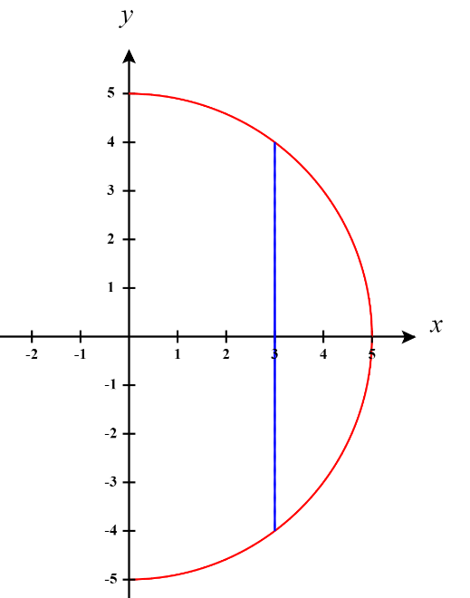
Therefore we can represent the volume of the solid that is removed by

Let , then .
The bound of the integral become and . So,

The total volume of the sphere being removed is .

